**Details and Screenshots of Project:**

Project on :- Asp.Net Web API

Operations:- PUSH,GET,PUT,DELETE

Database Used: SQL (Tool:- SQL Server Management Studio)

API testing tool: Postman

1. **PUSH Operation**

SQL Server table structure

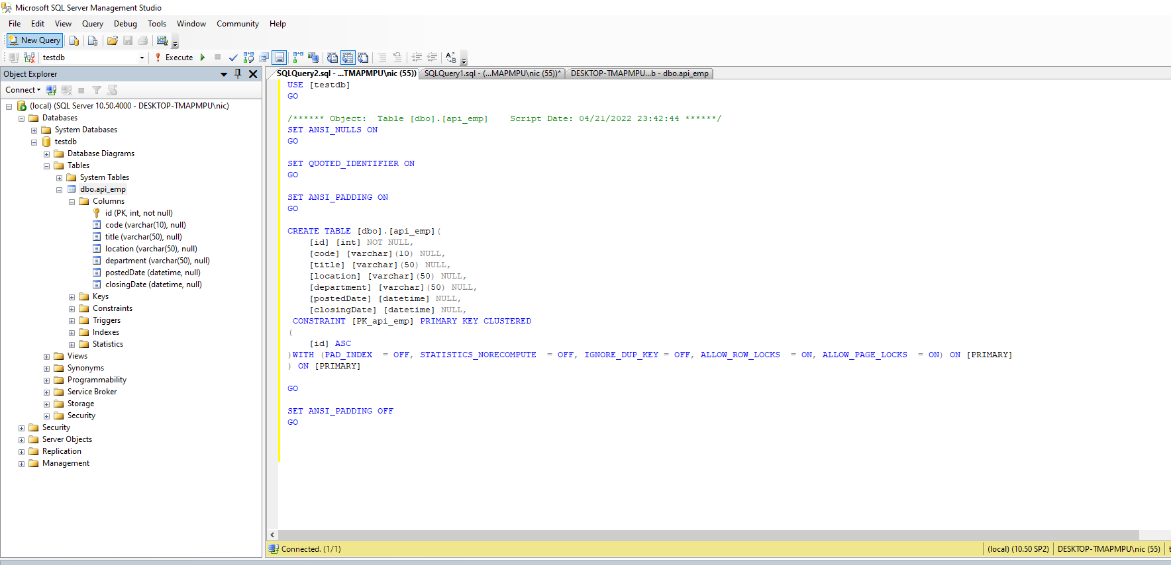

Postman Result

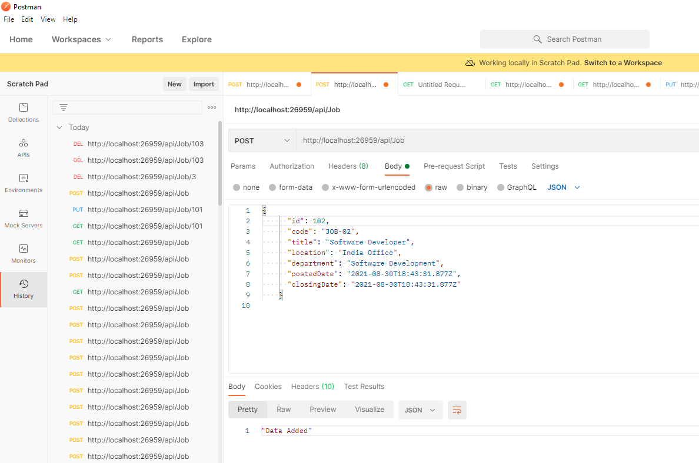

Post Results in SSMS

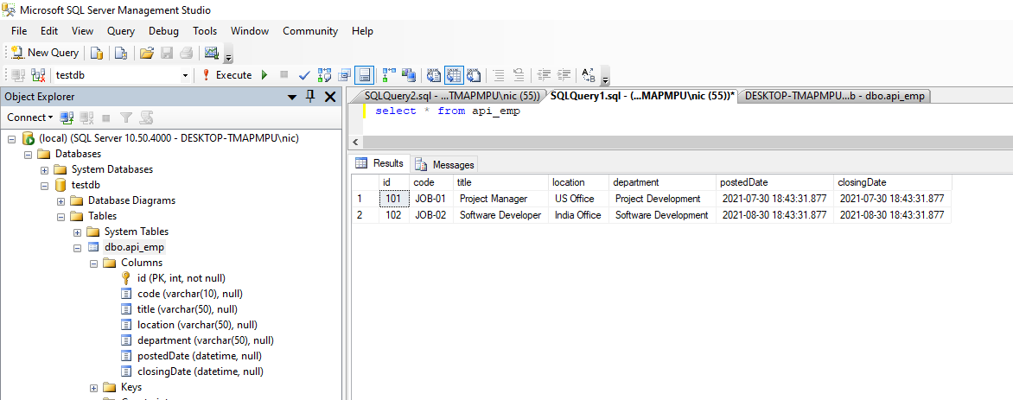

1. **GET Request for all records**

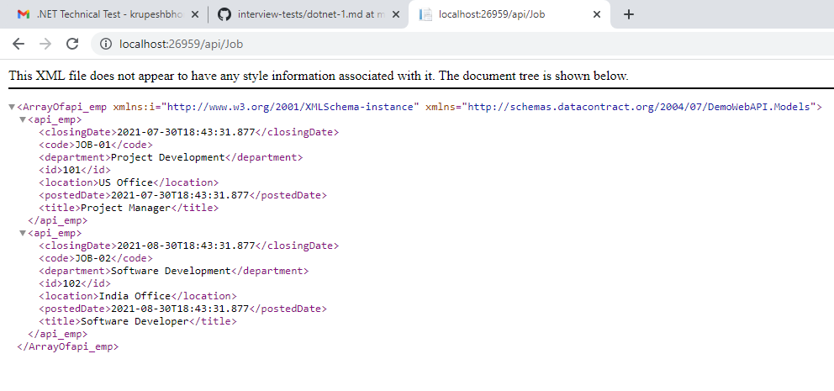

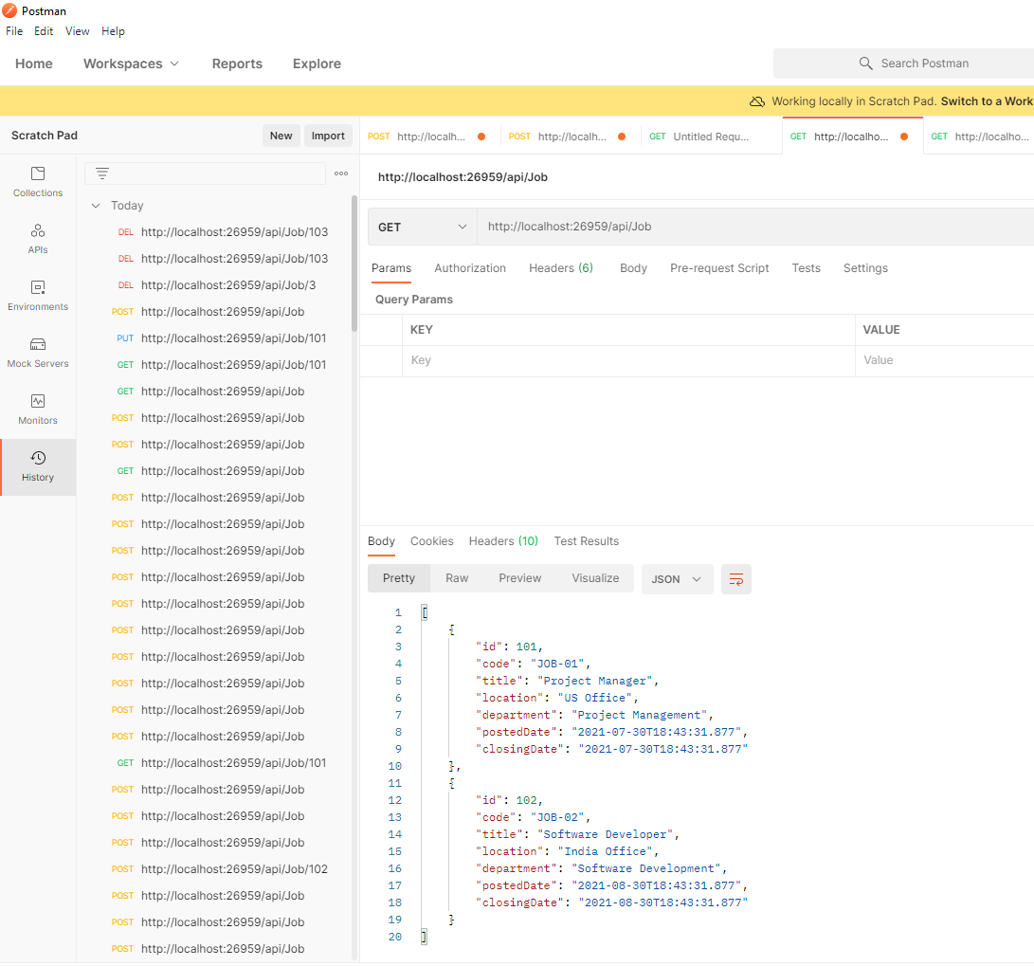

Get Based on Id

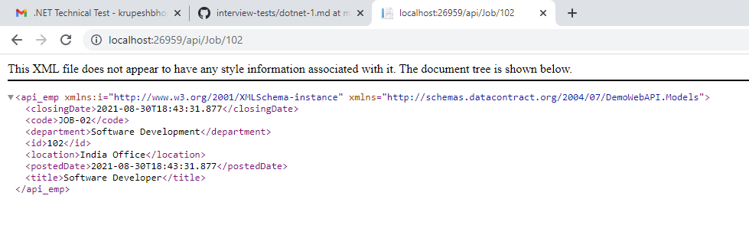

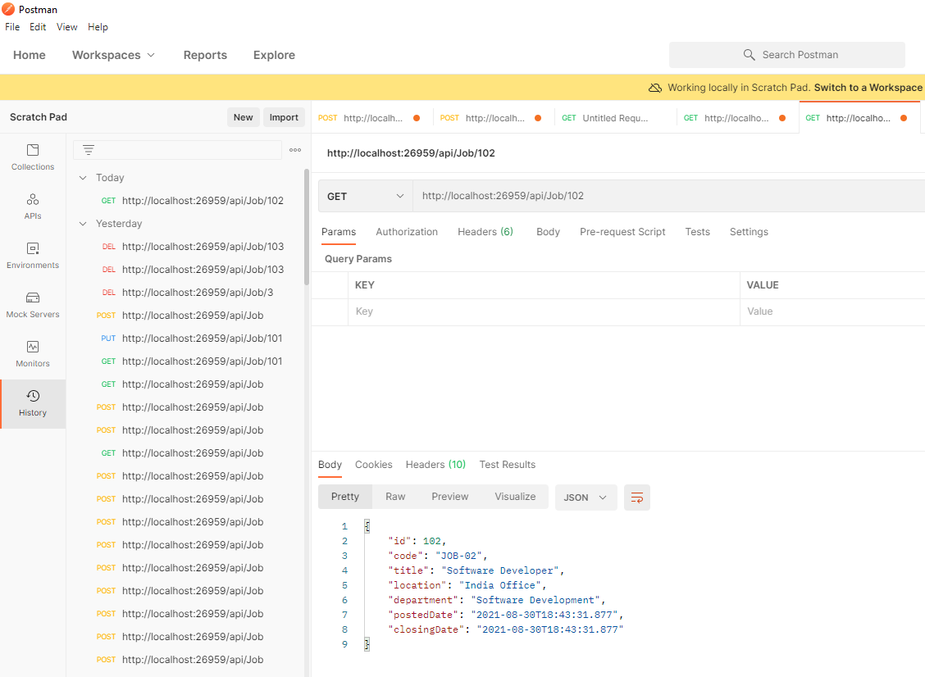

1. **PUT**

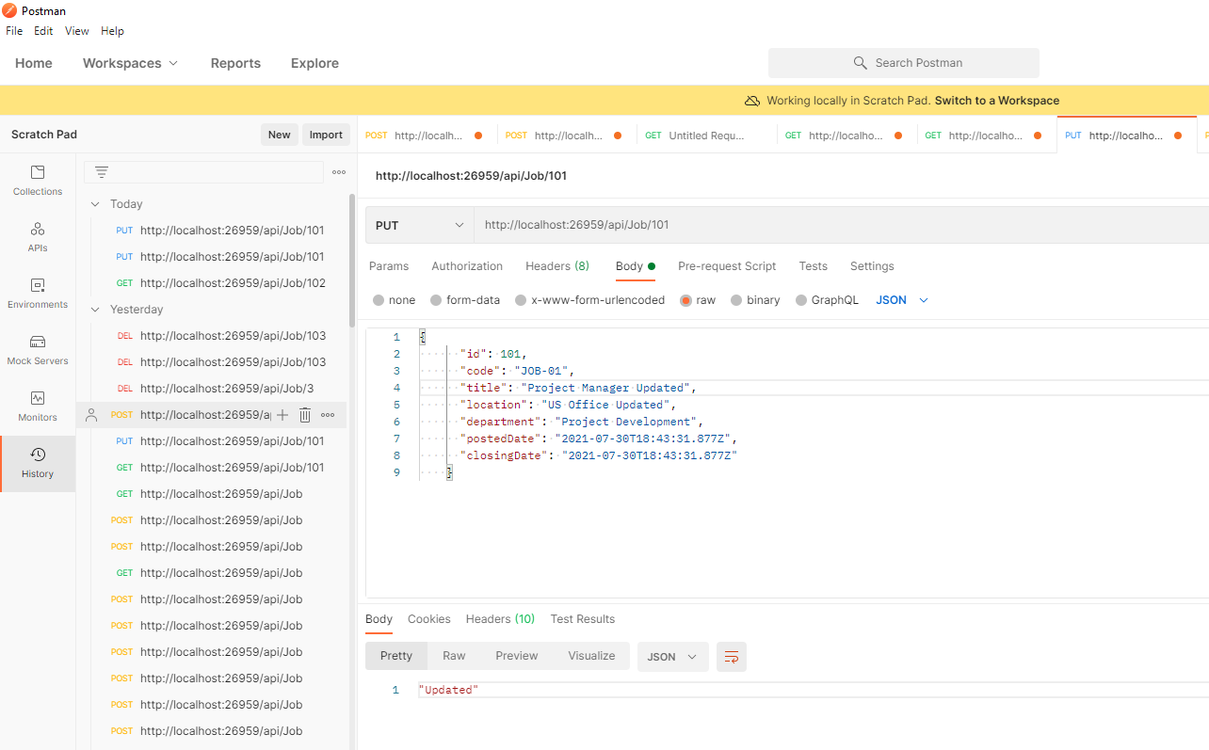

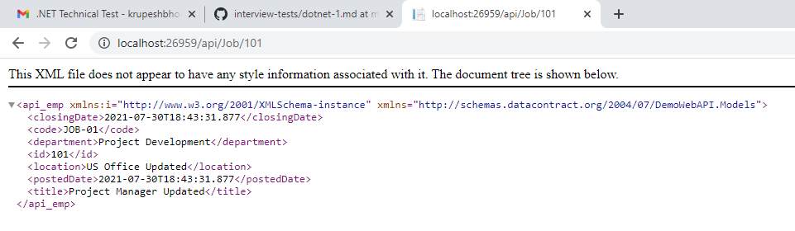

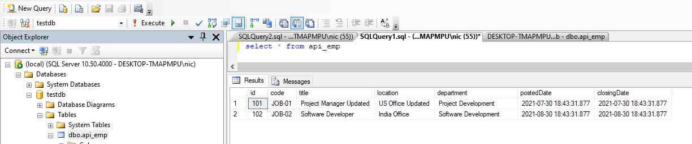

1. **DELETE**

